On windows Node

Step.1: From Jenkins Homepage Click On New Item

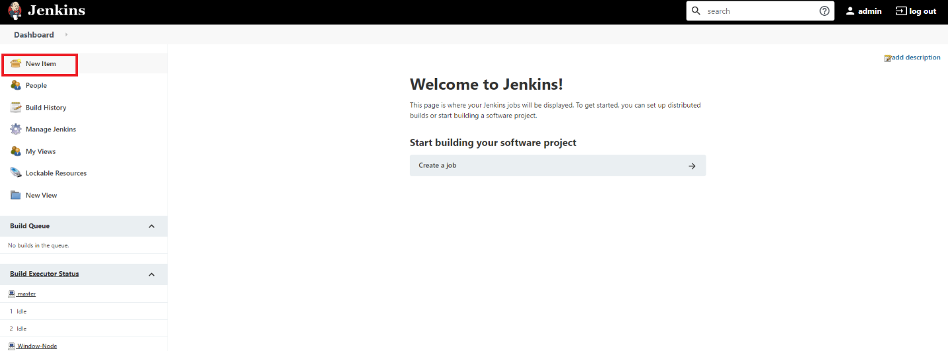

Step.2: Give It A Name **CloudEnabled-pipeline** Click on Pipeline And OK

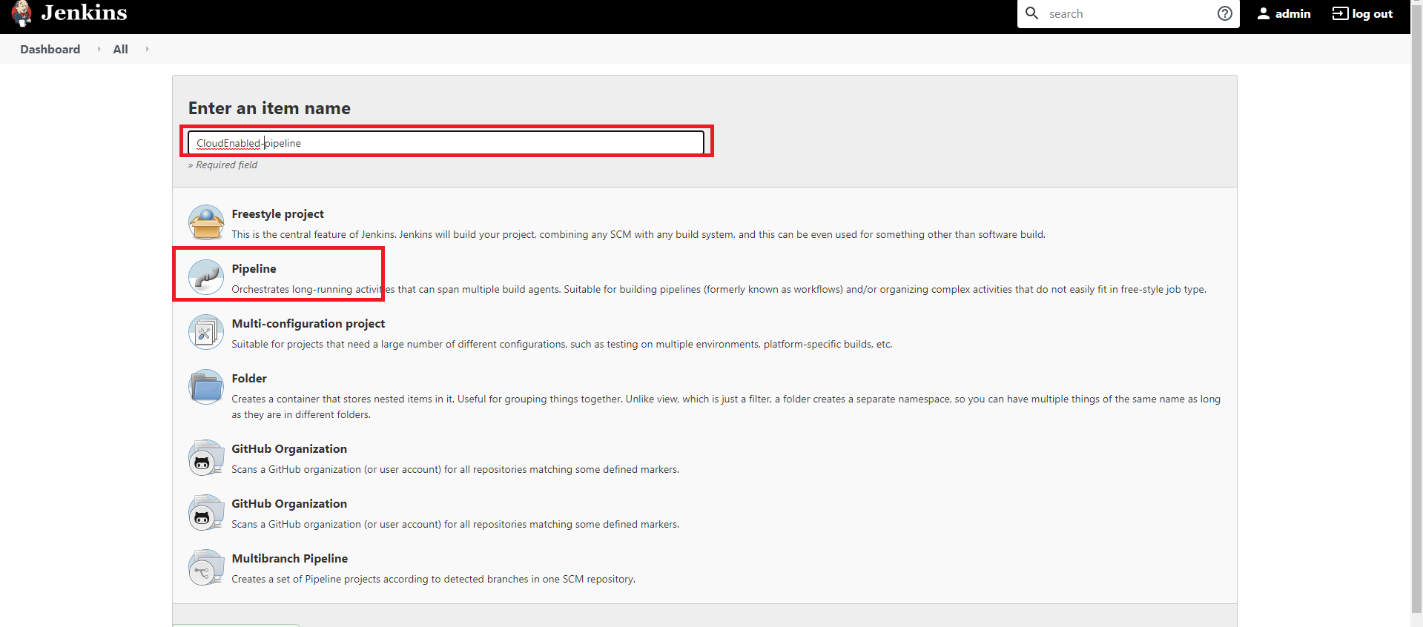

Step3: Click On Pipeline

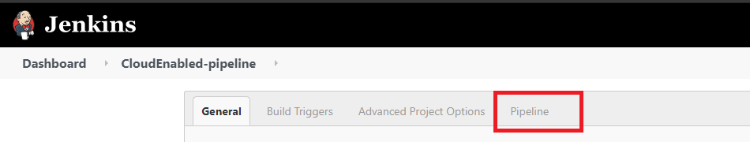

Step4: Copy And Paste This Script For Java Application

node('remote'){

stage('cloning')

git 'https://bidarianil@bitbucket.org/bidarianil/todorest.git'

stage('compile')

bat 'mvn compile'

stage('package')

bat 'mvn package'

stage('deploy')

bat 'start java -jar target/todorest-0.0.1-SNAPSHOT.jar'

}

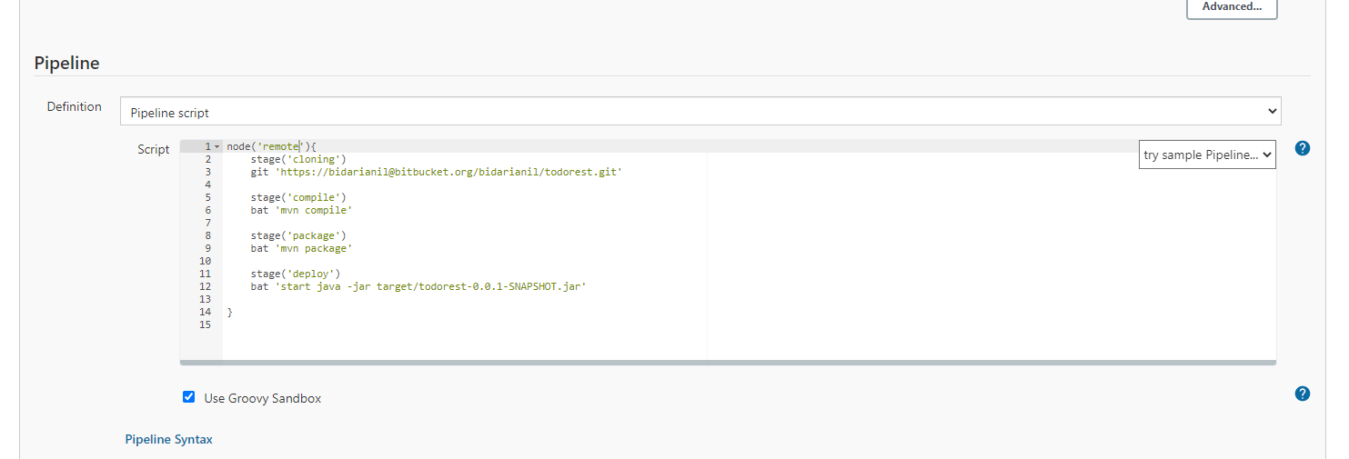

Step:5 Save It And Click On Build Now

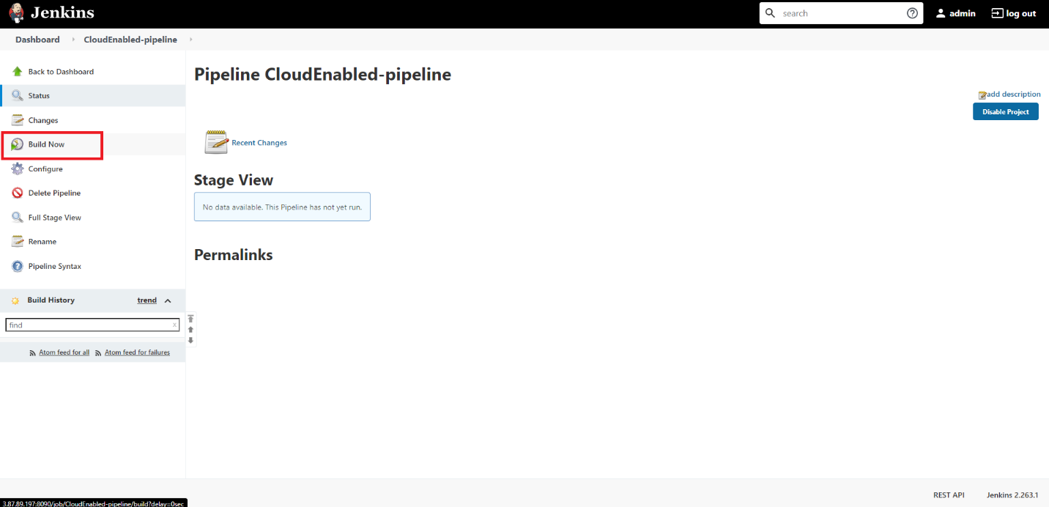

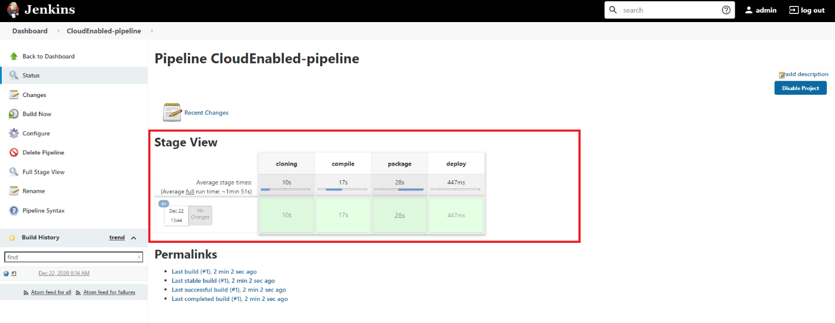

Step:6 Go To Your Browser And Navigate To Windows-Node IpAddress:8080

